News Release
FOR IMMEDIATE RELEASE

Jewers Sliding-Folding Doors Replace Roller Shutters at Doha and Rayyan Sewage Treatment Works
The installation of two sets of large Osprey sliding-folding doors completes the upgrade of the pumping station building, an integral part of the sewerage treatment works which services the regions of Doha and Rayyan in Qatar.
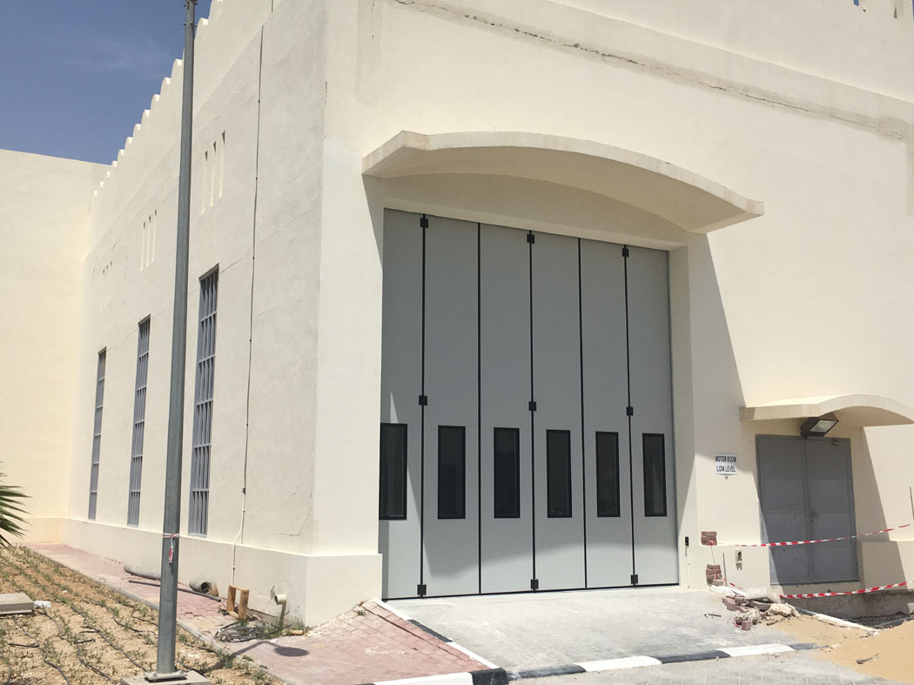
Ashgal, the public works authority for Qatar, commissioned Jewers Doors’ local reseller Rumaillah Warehouse Equipment to supply and install the doors, which are a far more robust system than the original roller shutters, which had suffered damage and regularly failed due to the high winds and other climatic factors experienced in Qatar.
Access to the front and back of the building is via two sets of 5 metre wide by 5 metre high doors, which can accommodate even the tallest of road vehicles without compromising headroom. Each door is configured in 6 leaves sliding and folding to one side and clear of the opening to provide a full clearance for traffic. Each door is electrically operated via a variable speed drive motor controlled by a fully programmable digital control panel incorporating lid mounted push buttons. For safety, each door is fitted with optical safety edges and presence detections systems to protect users during door operation.
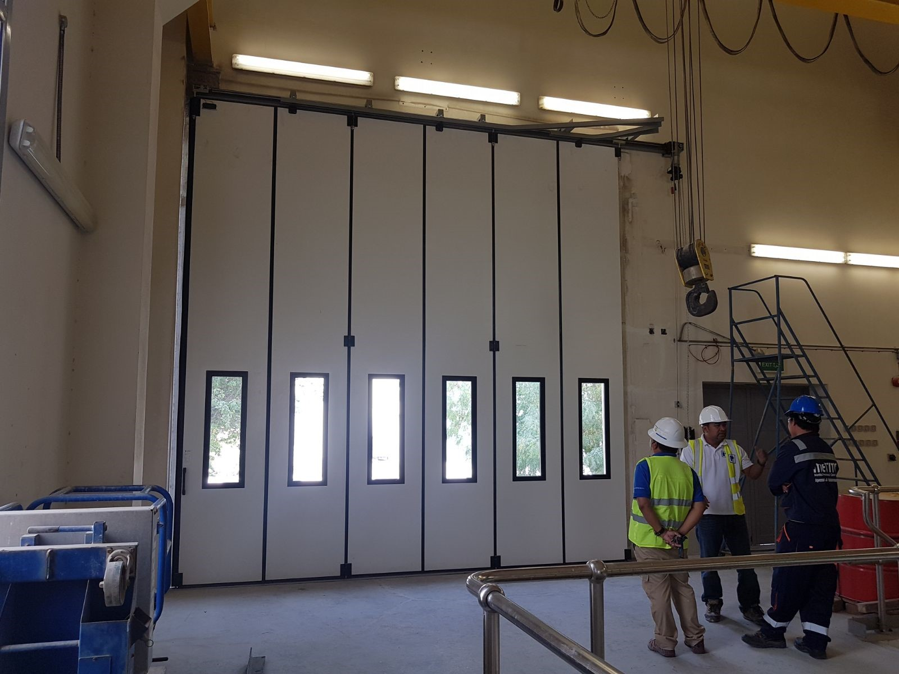
Doors are fully sealed against the harsh Qatar environment with weathertight EPDM seals to all edges, and each door panel incorporates a generous 400mm x 1200mm double glazed toughened glass vision panel in a thermally broken aluminium frame to provide visibility and light through the closed door. Door leaves are fully insulated with dense 50mm polyurethane and are finished with a light grey powder coating on the outside and an internal white Plastisol lining, which combine to virtually eliminate the heat from the sun transmitting through the door, whilst providing a long-lasting durable finish.
Jewers’ Regional Sales Manager; Ben Pritchard commented, “Jewers Doors have now been approved for installation by many government agencies in the Middle East. Not only do our doors meet the high standards specified for government installations, but the current exchange rate means we offer even better value. With our office in Dubai and locally based installers in each GCC country, Jewers are ideally placed to provide an excellent service throughout the Middle East.”
ends
Editor Notes
Hi- res images available on request
More about Jewers Doors
Established in 1983 and still a family run business, Jewers Doors is a world-leading supplier of industrial doors operating from a state-of-the-art facility in the heart of Bedfordshire. With over 60 highly skilled and experienced staff in UK and UAE, the core of the business is design, manufacture, installation and repair of industrial door solutions across all industrial sectors. The Phoenix range of doors are designed for medium to large industrial applications, while the Esavian range is recognised as one of the world’s leading range of aircraft hangar doors. Incorporating the very latest concepts and technologies, Jewers Doors have been installed not only in the UK, but also throughout the world including Europe, Middle and Far East and Australasia.

For more information visit www.jewersdoors.co.uk
Contacts
For media information
Colin Caldicott, Ultimedia PR
Tel: 01767 601470 Mobile: 07905 329616
e-mail: colin@ultimediapr.co.uk

