News Release

Ospreys Open New Airport Hangars at
Former Daedalus Site in Hampshire
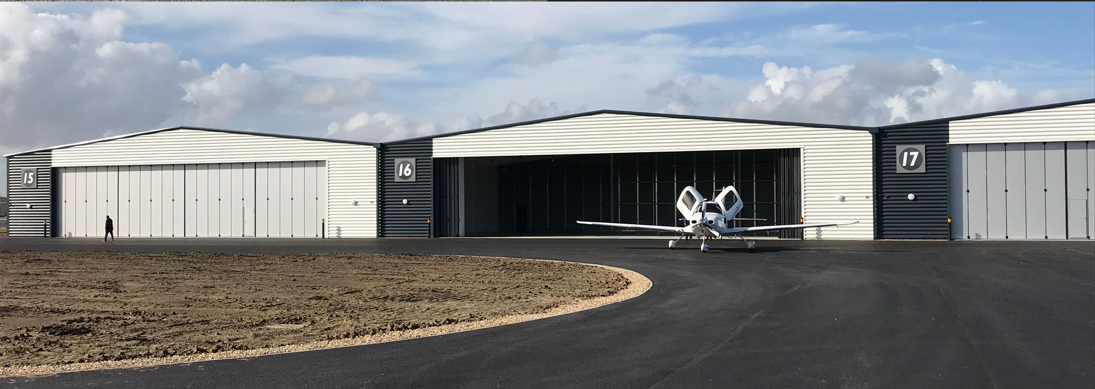
Jewers Doors have just installed eleven Osprey sliding folding hangar doors at Solent Airport in Hampshire, which completes the latest step in a £50m masterplan to transform the Deadalus site in Fareham, near Portsmouth, into a business airport.

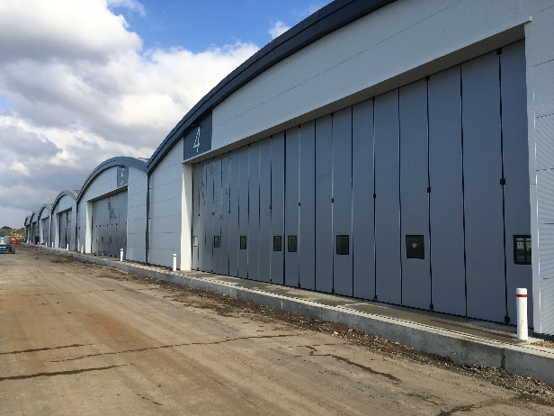
Andy Wannell, Director of Finance and Resources for Fareham Borough Council said, “This site has an aviation history that can be traced back for 100 years. When we acquired the site in 2015, our vision was for Daedalus to become a premier location for aviation, aerospace engineering and advanced manufacturing businesses. Our aim is for Solent Airport to become an attractive destination for visiting aircraft, but also offer the hangarage, facilities and services to attract more corporate and commercial aviation activities.”
“Storage facilities for aircraft were not only very limited but the hangars were built in the early days of the airport’s life. To ensure the facilities would meet the demands of a modern airport eleven new hangars were commissioned. Five are to accommodate private light aircraft for general aviation use and the other six for businesses in the aviation and aerospace sectors.”
Each general aviation hangar incorporates a 22.4m wide x 5m high manually operated Osprey sliding folding door system designed, manufactured and installed by Bedfordshire-based Jewers Doors. Each door comprises 24 folding leaves with 12 leaves bunching to each side of the opening.
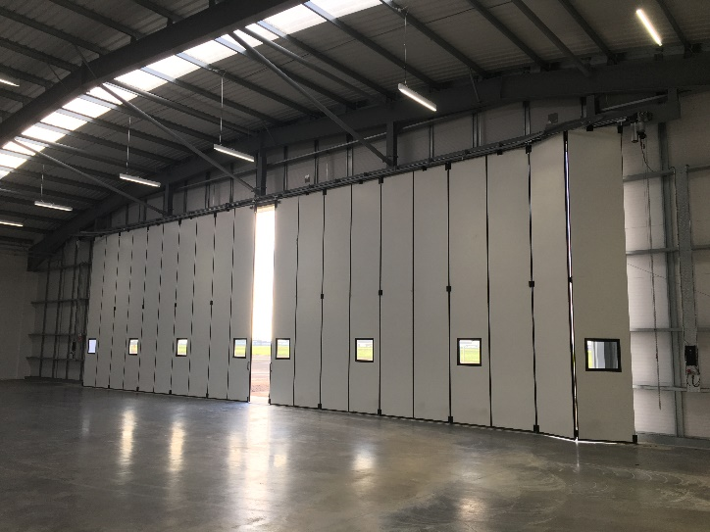
Each set of doors incorporates a wicket door for pedestrian access. In the closed position the doors are secured by internal, full-height lockable espagnolette bolts, which engage into the bottom and top track. A lever handle withdraws each bolt to enable door leaves to be easily pushed aside and allow full width entry.
Each business hangar is fitted with a 22.5m wide x 6m high, top hung Osprey door. Constructed using the same single-piece, highly insulated panel construction, purpose engineered hinges and soft compound weather seals as the GA hangar doors, the business hangar doors are electronically operated. Each door half, is driven by a powerful inverter controlled drive unit which moves each of the 10 leaves effortless across the opening and then folds them into a 1m² footprint behind the opening.

Wannell added, “The Daedalus site has already made a huge contribution to aviation history. This development will ensure that Daedalus will continue into the future, become a major aviation hub in the South as part of an Enterprise Zone creating many skilled employment opportunities for local people. We anticipate it will create 3,500 new local jobs over the next ten years."
ends
Notes to editors:
High res images available on request

More about Solent Airport
- Solent Airport currently has around 30,000 flights per year with a plan to grow this over the medium term.
- The cost of the General Aviation hangar development was approximately £2.6m.
- The cost of the business hangar development was approximately £3.5m
- The hangars have ample shared parking and will have access to a communal amenity building.
- The hangar development coincides with the expansion of the Innovation Centre at Solent Airport. The £7m extension will provide 3,400 square metres of new floor space, 33 new offices, five new workshops and spacious new conference facilities which is also now complete.

